 | MACDONALD HIGH SCHOOL  Student Leadership |  | 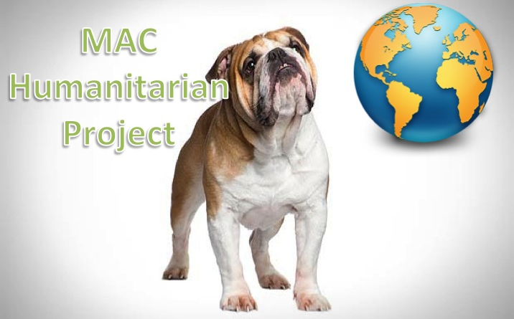
 | 17 rue Maple,  Ste. Anne de Bellevue, QC  H9X 2E5 | 514-457-3770  Fax: 514-457-8959
Dear Sponsor(s):

The MAC Humanitarian Project (MHP) was founded and is run by Macdonald High School graduating students. The goals of the project are simple, that is to generate a movement of young Canadians who will become responsible global citizens.

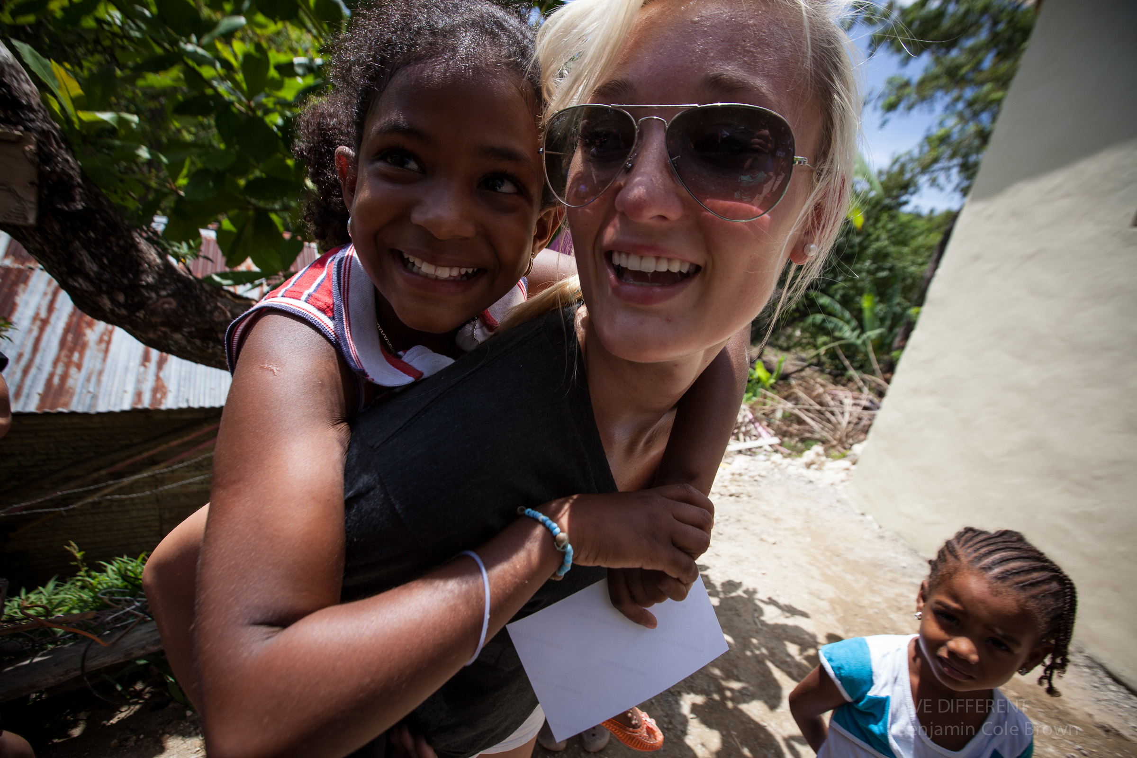
Each MHP participant has made a commitment to be a part of a team that hopes to make an impact on global poverty. According to Global Issues, The Human Development Report, a study released in July of 2012, 50% of the world’s population (over 3 billion people) live on less that $2.50 a day. An estimated 22 000 children die every day due to poverty. Related issues of statelessness, child malnutrition, child labour, human trafficking, and more, stem from families having to deal with extreme poverty. This is a universal concern because this is the generation that has enough global resources to ensure that everyone can regularly have access to the basic necessities of life, that is, shelter, food, clean water, and education, the first steps towards ending poverty. MHP students have partnered with Habitat For Humanity (HFH) and together, are working towards providing sustainable development in communities of around the world.

Last year, 19 Macdonald High School students travelled to Vicente Guerrero, Mexico. Together with other young Canadians, they were able to build and furnish 3 homes for 3 different familes. At the end of the 10-day trip, lives were positively changed forever, those of the receiving families, and of the Reyes Family in the Dominican Republic, and those of the 19 students, who will never again believe that they cannot be a positive force in the world. This summer we will be our fourth humanitarian effort. We anticipate that many Mac High students will sign up for the MHP project, and approximately 30 students will be travelling to the farming community of Siguatepeque, Honduras. Over the course of 10 days, we will be actively engaged in the community and building a home for another 3 families.

The total cost of the trip for each student will be approximately $2630. This amount covers the cost of travel and materials required to build the home. Your support will be instrumental in providing an eye-opening learning experience for those students who could not otherwise fund their own trip. Because of the charitable nature of this trip, donations of $20 or more towards the students' fees are eligible for a charitable donation tax receipt.

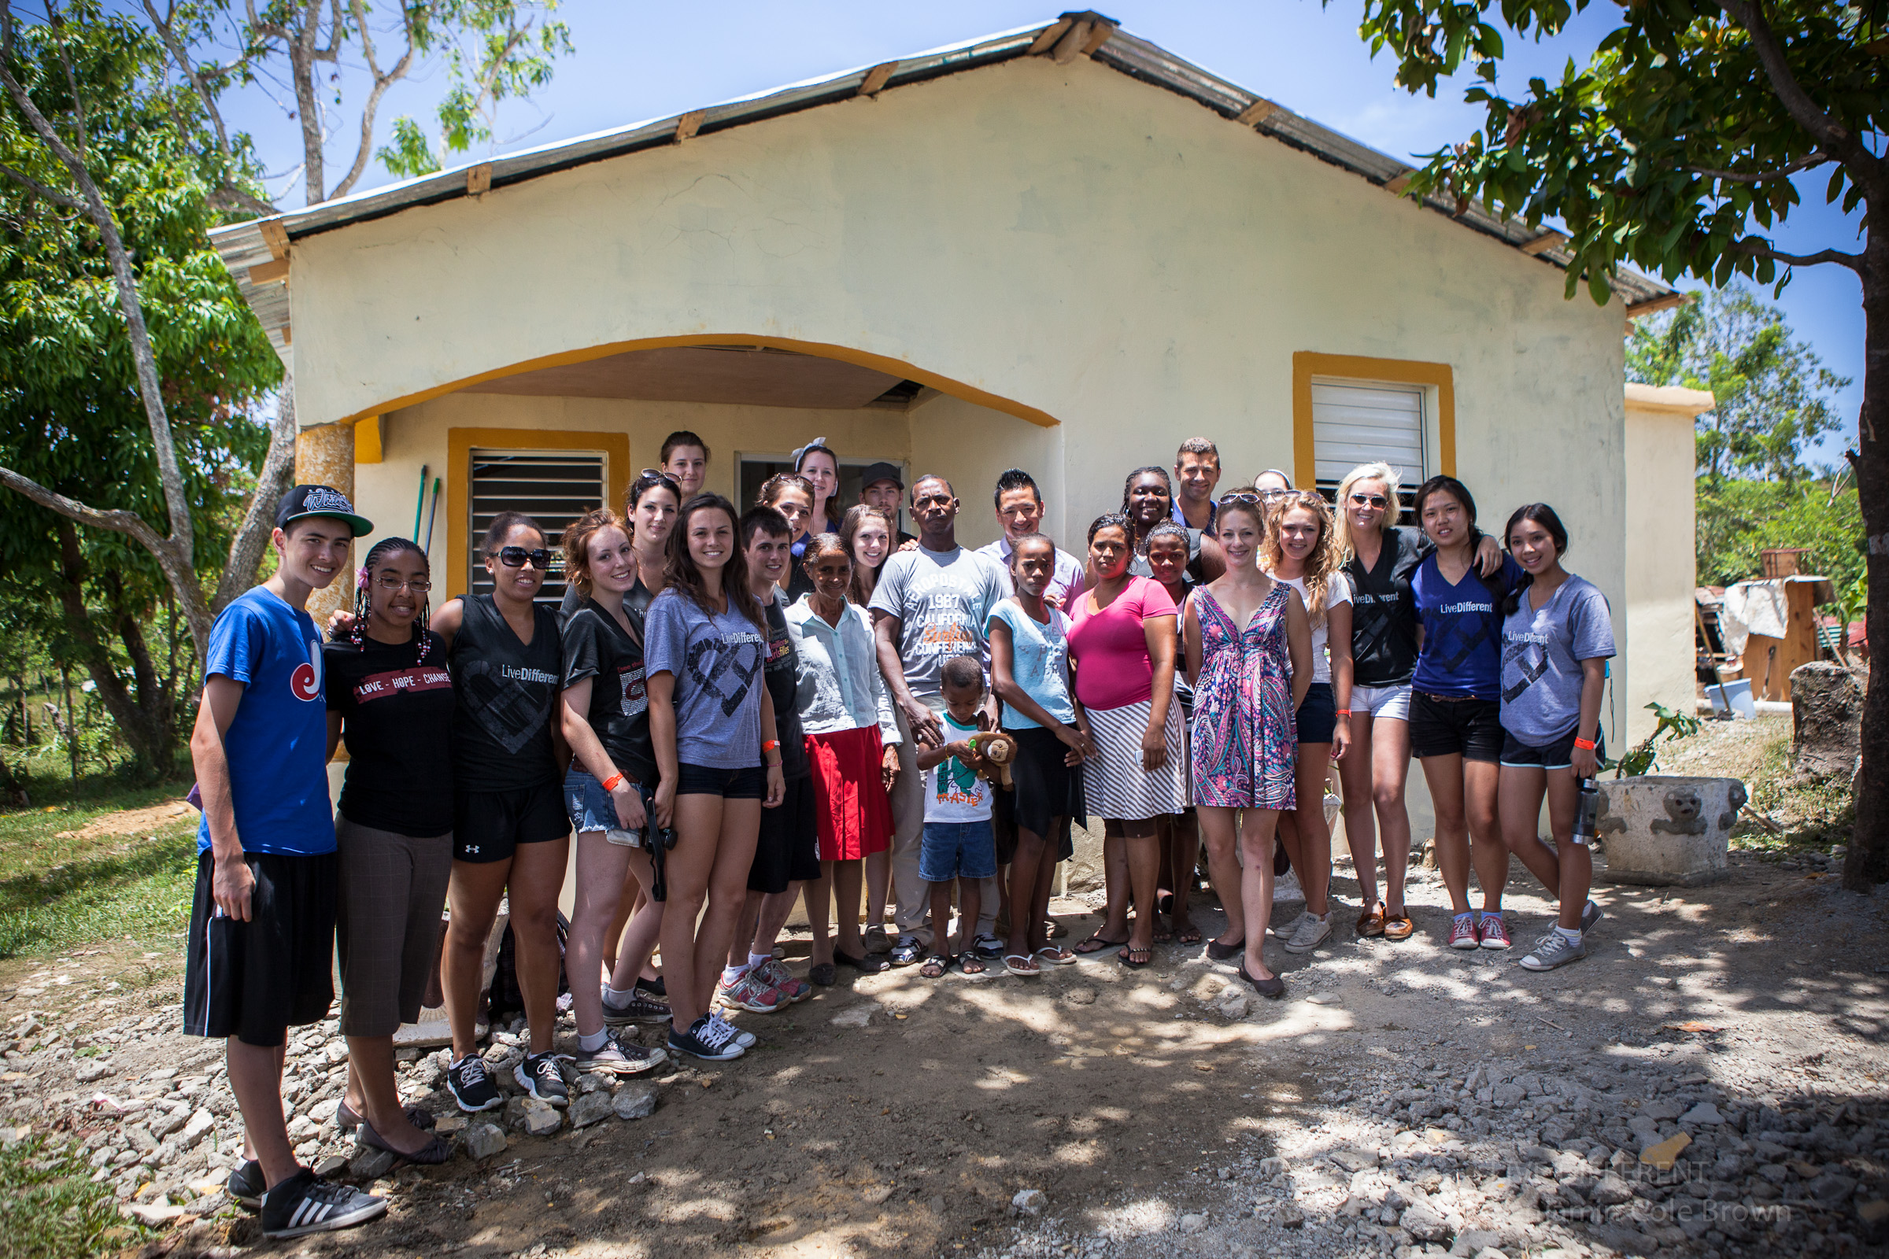
The students are hopeful that a majority of the cost will be covered by various fundraising activities. MHP places an emphasis on working together to raise awareness and donations through a number of fundraising projects in and around the Macdonald High School community. Participants are encouraged to contact businesses, friends and family members and engage in conversations surrounding the issues of global poverty.

This will be an incredible opportunity for our students. After an eventful year of semi-formals, trips to Florida and Europe, proms, etc., exposure to the extreme needs in one of the poorer regions in the world will strike a contrast that can only be experienced first-hand.

Thank-you for your interest in our program. Together, we can help shape the futures of not only the needy families of a developing community, but also invest in developing the positive energy of our Canadian youth. For more information on our trip and our project, please feel free to contact me directly, or take a closer look at our projects at http://machumanitarianproject/weebly.com .
Sincerely,


Chris Martin-Chang
Macdonald High School,
Student Leadership Advisor, cchang04@lbpearson.qc.ca

